Appendix 1

(Proforma for the certificate for internship in official letter head)

**CERTIFICATE**

This is to certify that Mr/Ms. Asma Shaikh of R. J. College worked as an intern as part of his/her MSc course in Statistics.   
The particulars of internship are given below:

Name of the company: _ Bennett, Coleman and Company Limited – Television Division

Internship starting date: 9th Jan to 28th April 2023(in service)

Internship ending date: 9th July 2023

Actual number of days worked: 5 days weeks

Tentative number of hours worked: 40 hours per weeks

Broad area of work: _Consumer Research & Data Analytics

A small description of work done by the intern during the period:

Analyzing content and viewership data and giving feedback using SWAT for our channels as well as competitions from various sources of data like YUMI, GA, Comscore, You tube…..

Yours Sincerely,

For, Bennett, Coleman and Company Limited – Television Division

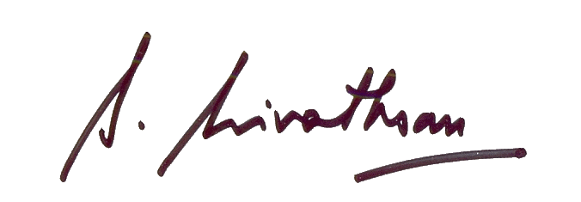

S. Srivathsan

Head - Human Resources

Times Network

Appendix 2

(Performa for the Evaluation of the intern/employee by the supervisor/to whom the intern/employee was reporting in the organization)

**Professional Evaluation of intern/employee**

Name of intern/employee: Asma Shaikh

College/institution: _ Ramniranjan Jhunjhunwala College___________

[Note: Give a score in the 1-5 scale by putting **✓** in the respective cells]

|  |  |  |  |  |  |  |
| --- | --- | --- | --- | --- | --- | --- |
| **Sr. No.** | **Particular** | **Excellent** | **Very Good** | **Good** | **Moderate** | **Satisfactory** |
| 1 | Attendance |  |  |  |  |  |
| 2 | Punctuality |  |  |  |  |  |
| 3 | Adaptability |  |  |  |  |  |
| 4 | Ability to shoulder responsibility |  |  |  |  |  |
| 5 | Ability to work in a team |  |  |  |  |  |
| 6 | Written and oral communication skills |  |  |  |  |  |
| 7 | Problem solving skills |  |  |  |  |  |
| 8 | Ability to grasp new concepts |  |  |  |  |  |
| 9 | Ability to complete task |  |  |  |  |  |
| 10 | Quality of work done |  |  |  |  |  |

Comments:

_Wish you all the best for your future ________________________________________________________________________________________________________________________________________________________________

Yours Sincerely,

For, Bennett, Coleman and Company Limited – Television Division



S. Srivathsan

Head - Human Resources

Times Network